**Custom Training – Day**

**September 13, 2023**

**Topic – Power BI**

* Power Query – Data transformation and data preparation tool included within the Power BI and Microsoft Excel. It streamlines the process of importing data from a variety of file types like excel tables, CSV files, webpages and allows you to transform your data into proper shape and condition for better analysis. It uses M language. For visualization we will use DAX expression. (Data Analysis Expression)

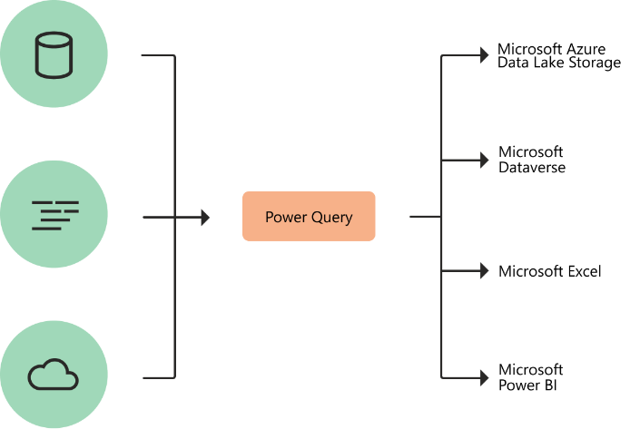

* Power Pivot
* Power Map
* Power View

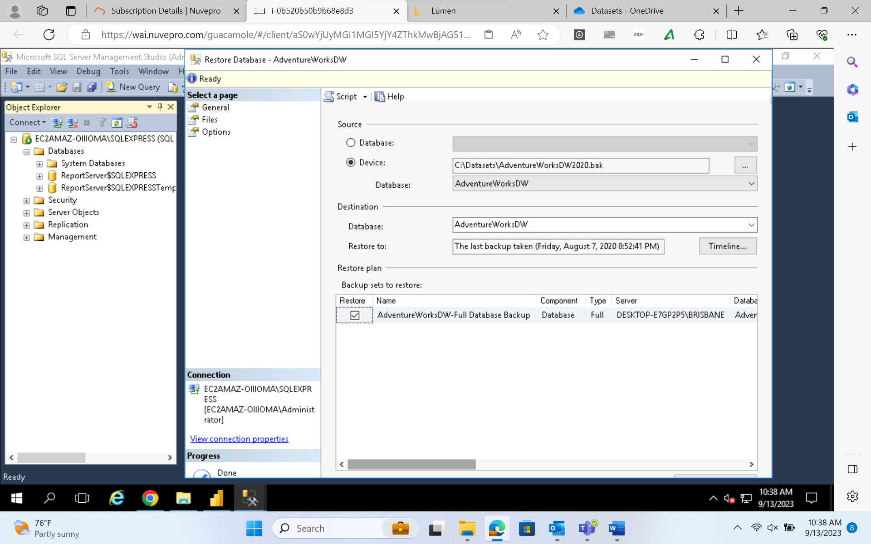

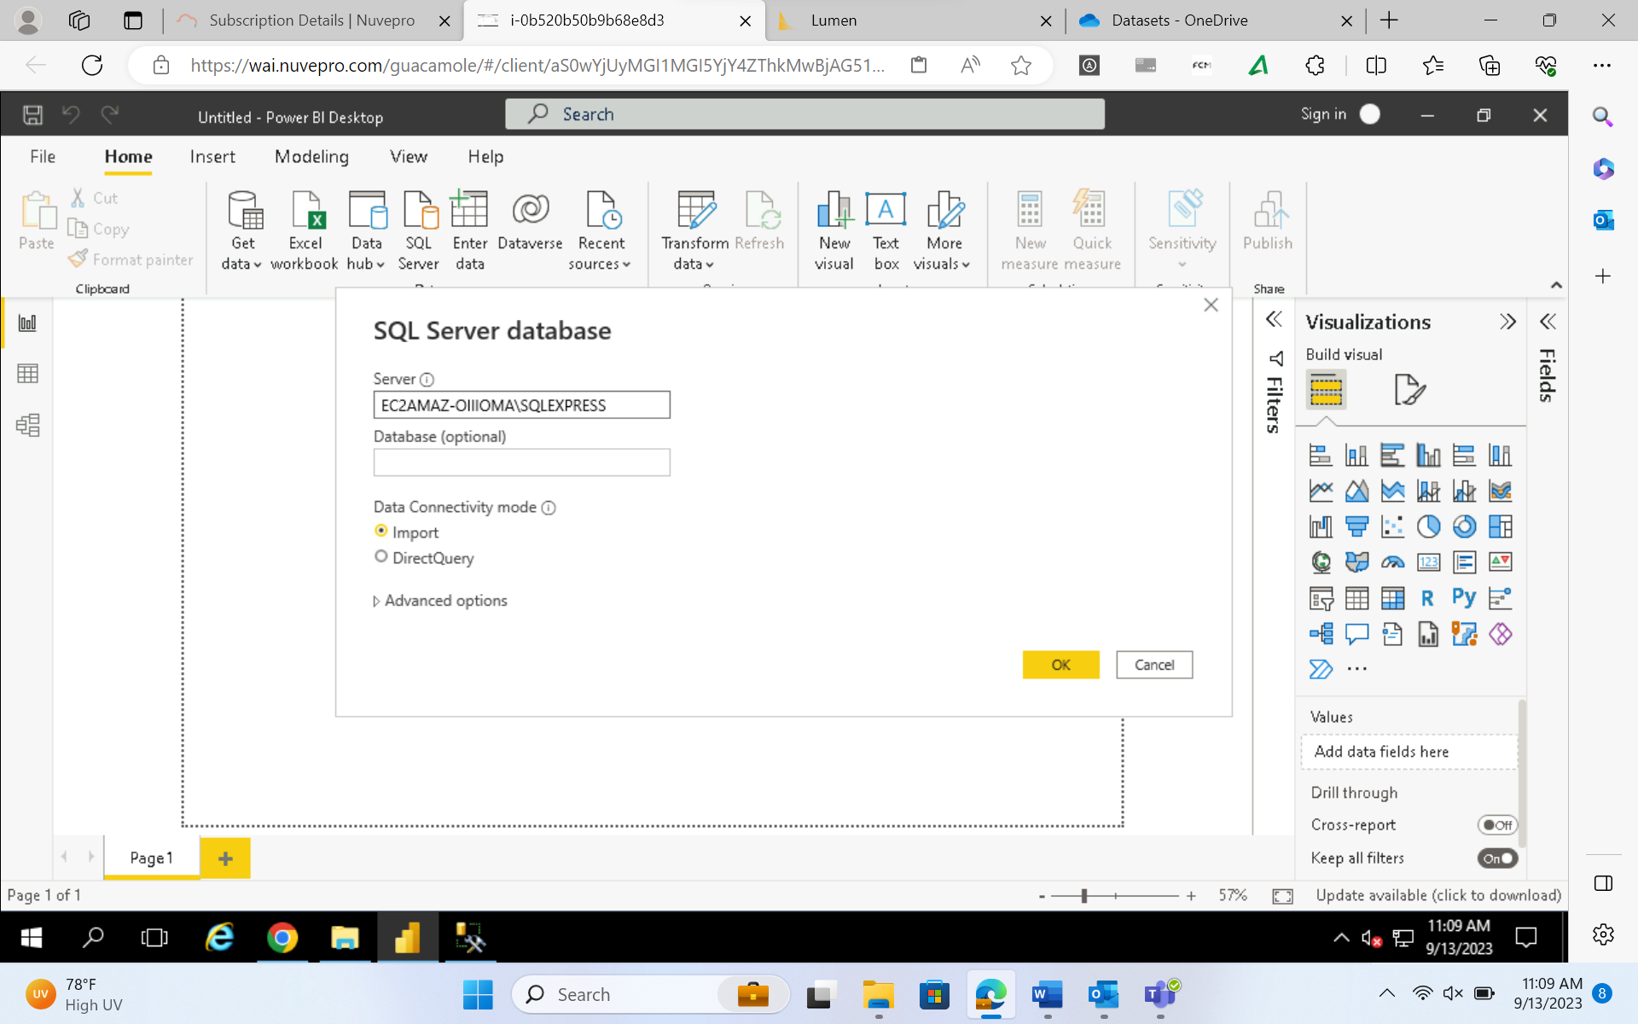

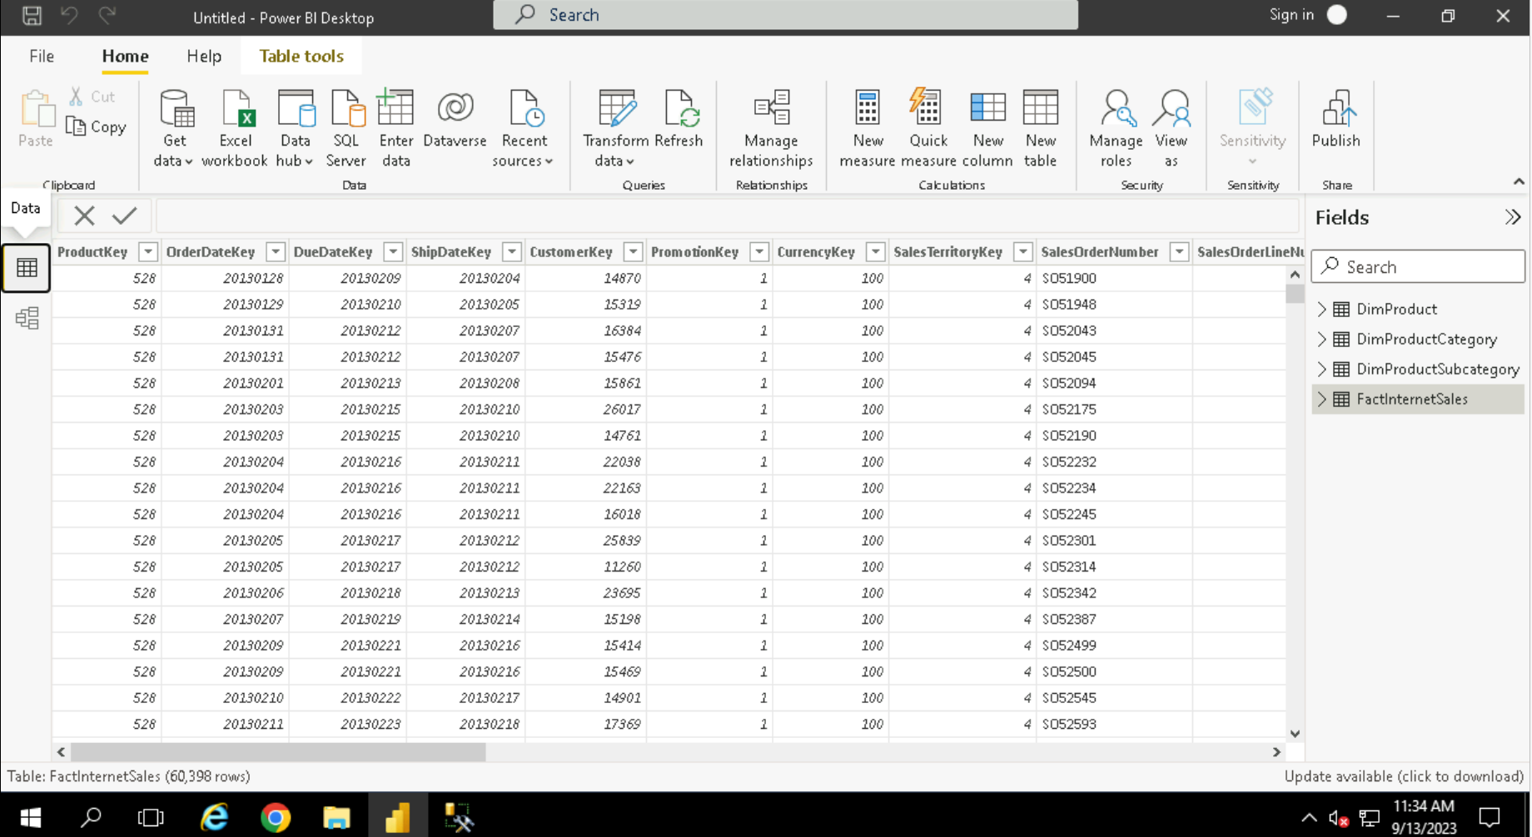

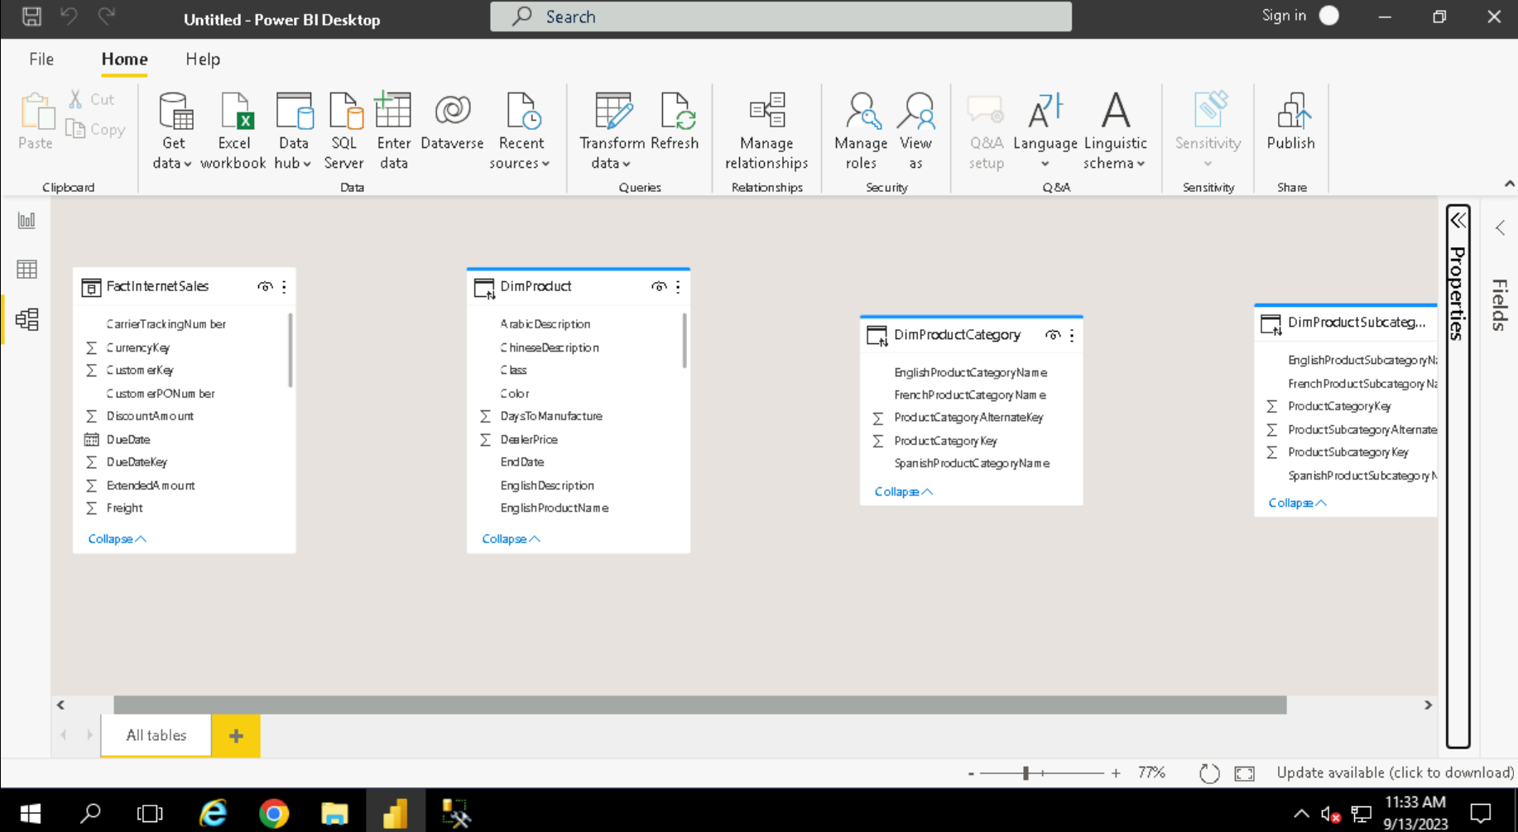

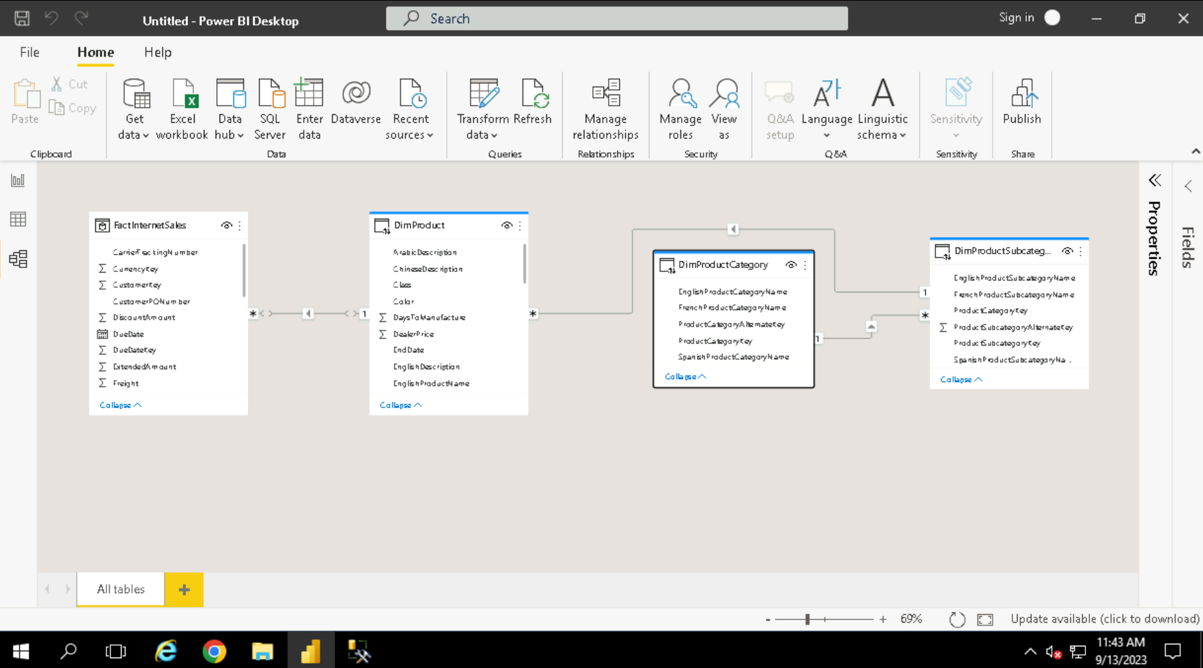

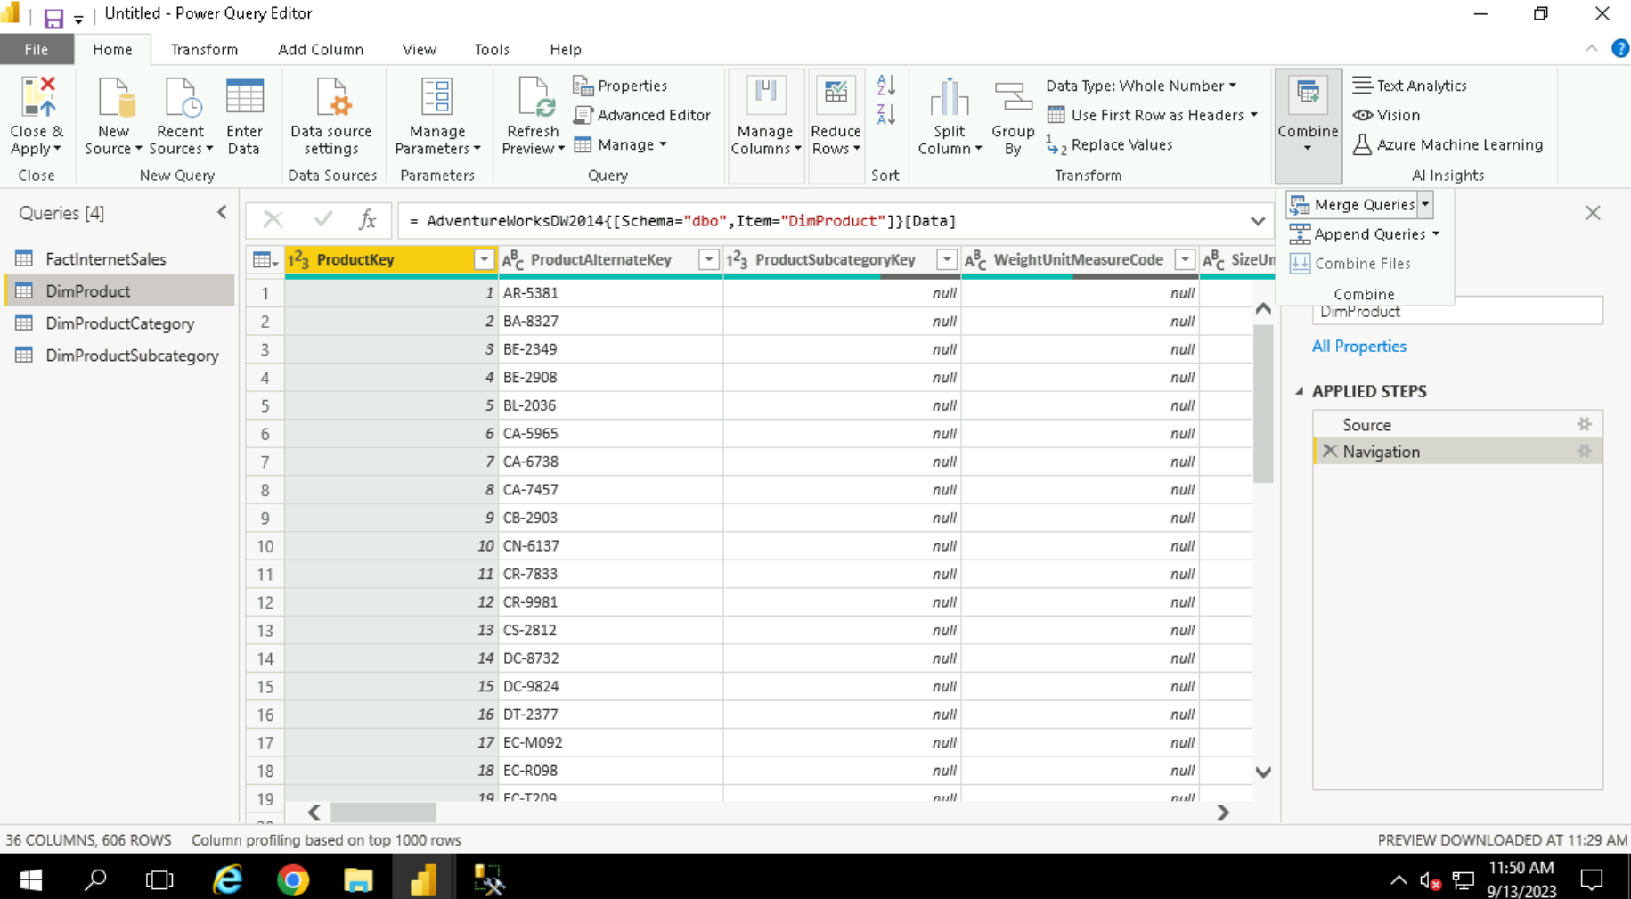

Merge query => Join

Append Query => Union/UnionAll

